CSS 422

Jun Hyung Park

Homework 4

**Q1. (10pts) Cache and Memory mapping**

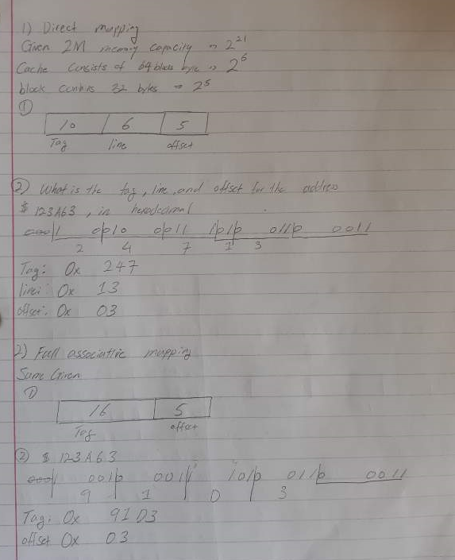

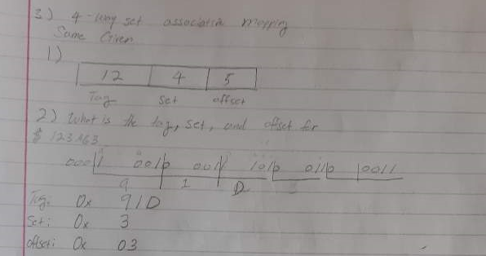

**Q2. (10 pts) Cache hit and miss**

1,    What is the hit ratio for the entire memory reference sequence given (in bold)?

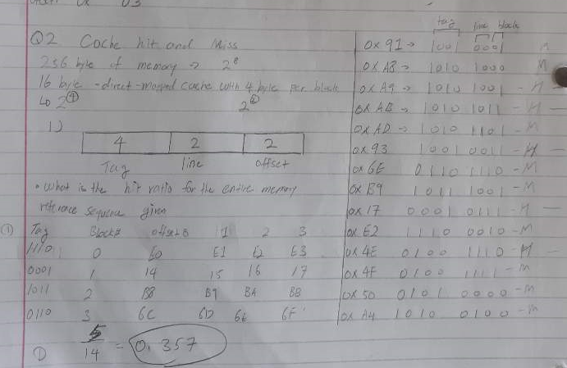

2.    What memory blocks will be in the cache after the last address has been assessed?

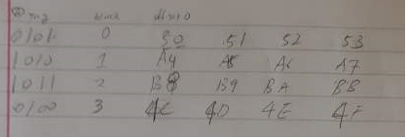

**Q3. (10 pts)  Virtual memory and cache**

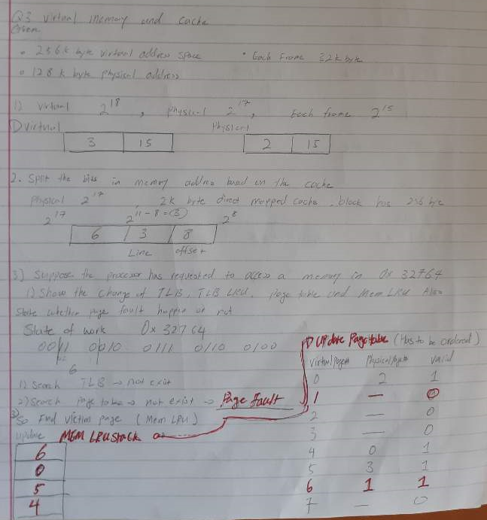

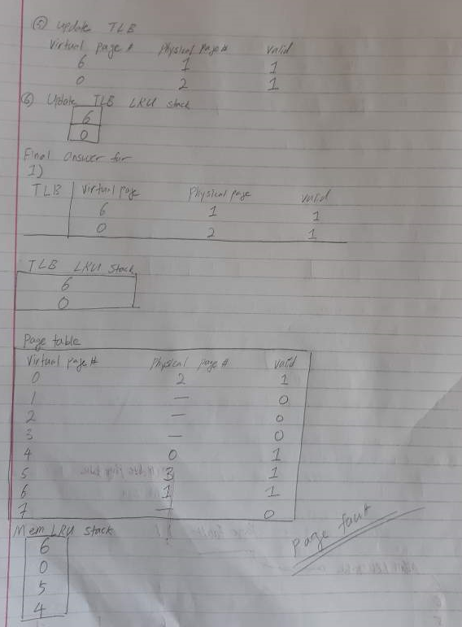

2) Show the changes in Cache.

